- 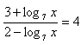
- log 3 (5 +4. log 2 (x-1)) = 2

- 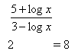

- 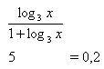

- log (x +5) - log (x-1) = 1-log2

- log (x +2) + log (x-7) = 2.log (x-4)
- log5x + log (2x + 3) = 1 + 2.log (3-x)
- log (1 + x)-log (1-x) = log (x +3)-log (4-x)
- 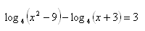
- 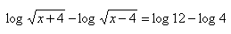
- 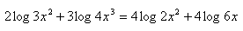
- 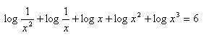
- log₃(2^{x} - 7) = 2
- log₂( 9- 2^{x}) = 3 – x
- log₃( 1 + log₃(2^{x}-7)) = 1
- log₃(3^{x}- 8) = 2 – x
- 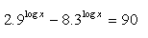
- 
- 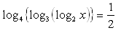
- 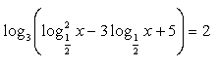

- 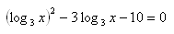
- Rovnica log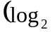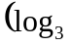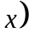 = 0 má v R jediný koreň, ktorý leží v intervale: 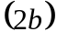
A 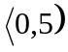 B 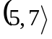 C 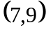 D 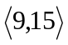
- Jediný koreň rovnice log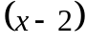 = log 2 + log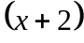 - 1 leží v intervale:
A 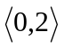 B 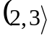 C 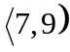 D

